Analyzing a Line Graph – An Exercise

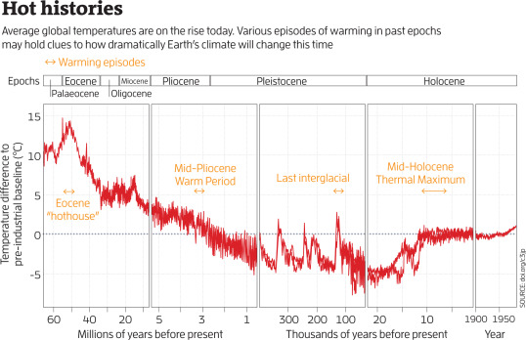
G. Lawton, “Climate's future written in rocks”, NewScientist, 6 July 2019, pp. 38-42

